Contribution of Geothermal Energy to Passive Cooling of Living Spaces in Benin: An Air-ground Heat Exchanger Approach

Ahonankpon Hubert Frédéric GBAGUIDI¹, Julien YOVOGAN1, Koffi Judicaë^{l} AGBELELE², Yémalin Daniel AGOSSOU³, Chéissou KOTO TAMOU³, Alexis F. TOGBE¹

¹Research Unit in Sustainability of Urban Infrastructure and Services, Laboratory of Geosciences, Environment and Applications (LaGEA), National University of Sciences, Technologies, Engineering and Mathematics (UNSTIM), Abomey, Benin

²School Multidisciplinary Research Laboratory for Technical Education (LARPET), National University of Science, Technology, Engineering and Mathematics (UNSTIM), Abomey, Benin

³Laboratory for Studies and Tests in Civil Engineering (L2GC), National University of Sciences, Technologies, Engineering and Mathematics (UNSTIM), Abomey, Benin

doi.org/10.51505/ijaemr.2025.1213 URL: http://dx.doi.org/10.51505/ijaemr.2025.1213
Received: May 20, 2025 Accepted: May 26, 2025 Online Published: Jun 02, 2025

Abstract
In a context of global warming and high demand for air conditioning in tropical areas, surface geothermal energy offers a sustainable solution for thermal comfort. This study explores the applicability of air-to-ground heat exchangers (or Canadian wells) for passive cooling of homes in Benin. It is based on a literature review, an analysis of local climate data, and modeling of the thermal behavior of a system adapted to the Beninese context.

Keywords: sustainable architecture, bioclimatic, surface geothermal energy, Canadian well, air-ground heat exchanger

1. Introduction
Benin, located in a humid tropical zone, experiences a hot and humid climate in the south, and a hot and dry climate in the north. In urban areas, many residents leave their rooms indoors for several months of the year to sleep under the stars to escape overheating. The need for air conditioning is therefore constantly growing, and energy-intensive mechanical air conditioning remains expensive and often inaccessible for the most vulnerable populations. In this impasse, very low-energy geothermal energy constitutes an ecological and economical alternative that exploits the almost constant temperature of the ground at shallow depths via air-ground heat exchangers, also called Canadian wells or Provençal wells.

The air-ground exchangers (EAS), according to Chtioui (2023), are passive geothermal systems that use the thermal inertia of the ground to preheat or cool the air entering a building. El-Maktoume (2023) adds that outside air is channeled through buried ducts, where it exchanges heat with the ground, before being introduced into the home. This process reduces the need for heating in winter and air conditioning in summer, thus contributing to the energy efficiency of buildings (Batier, 2016).

In order to adapt it to the Beninese context, this reflection proposes to analyze the favorable factors as well as the constraints for the development of this technology. The ultimate goal is to substantially reduce the interior heat of living rooms and thus offer appreciable thermal comfort.

2. Method
The aim of the study was to reduce the indoor heat of rooms in homes in the cities of Benin, a four-step approach was adopted.

Initially, a documentary analysis (scientific sources, climate, and pedological databases) helped to clarify the problem and review recent experiences. The study of the design parameters (pedology, climatology) then led to contextualizing the problem. A schematic modeling of the Air-Ground exchanger system then demonstrated the feasibility of such technology, while the development of a design scenario for a standard house led to prototyping of the solution.

3. Results and discussion

3.1 Operating principle of air-ground exchangers
Very low-energy geothermal energy is based on the principle that the temperature of the ground at a depth of 1.5 meters remains relatively stable throughout the year. On this basis, air-ground heat exchangers (or Canadian wells) consist of circulating outside air in conduits buried at a depth of 1 to 2 meters to pre-cool the air entering a home by circulating it in buried conduits before its introduction into the living areas (Kaboré et al. (2017)).

This ventilation system, which uses the stable temperature of the ground to preheat or cool the air entering a building, can be represented by the figure below.
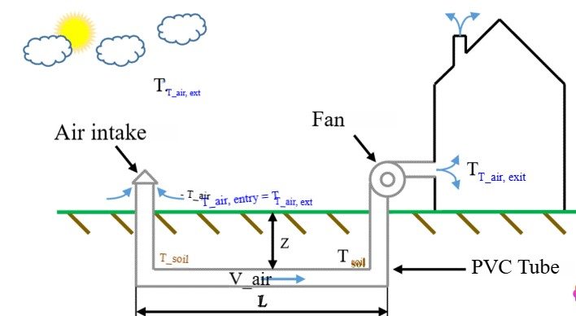
Figure 1: Operation of an air-ground exchanger

In this system, outside air is drawn in through inlets and circulates through ducts buried at a depth of 1.5 to 2 meters. It cools on contact with the ground before being blown into the building, thus contributing to indoor thermal comfort.

3.2 Review of regional experiences and applicability to the Beninese context
Although there are no specific studies in Benin yet, research conducted in countries with similar climates offers interesting perspectives. In Ouagadougou, Burkina Faso, an experiment demonstrated that an air-ground heat exchanger could reduce the temperature of the incoming air by 5 to 7°C compared to the outside air, with very low energy consumption, limited to that of a 15 W fan (Kaboré (2017)).

Similarly, a study conducted in Algeria, Belloufi Y. et al. (2016) showed that the air temperature at the exchanger outlet tends towards that of the ground, with significant thermal gains, depending on the nature of the soil, the burial depth, the length and diameter of the ducts and the air circulation speed. These experiments therefore, highlight the technical feasibility of the solution and the need for adaptation to the local context.

In light of these conditions, a verification of the parameters for using surface geothermal energy showed that high temperatures and high levels of sunshine create an increased need for cooling and therefore constitute a favorable climate for deploying this technology. Similarly, the performance of an air-ground heat exchanger depends heavily on the thermal characteristics of the soil, including its thermal conductivity, thermal capacity, and moisture content. In Benin, Youssouf, et al (2002) identified that the main soil types are:
- Tropical ferruginous soils occupying about 65% of the territory are generally well drained but have moderate thermal conductivity.
- Little developed soils. In a proportion of approximately 20%, their thermal conductivity varies depending on their composition.
- Ferralitic soils occupying 10% of the territory are rich in clay and have good thermal capacity, favorable to the operation of EAS.
- Hydromorphic soils: about 3% of the territory is saturated with water with high thermal conductivity which can improve the efficiency of EAS, but their use requires precautions to avoid excessive humidity in the ducts.

Finally the vertisols occupying 2% of Benin are expansive clay soils with good thermal capacity but can pose stability problems for buried conduits.

Since the stability of the ground temperature is an ideal asset for heat exchange, it therefore seems clear that the thermal conductivities analyzed above constitute assets for the implementation of this technology. Furthermore, it follows from these data and field observations that the deployment of the solution in Cotonou, for example, is based on three (03) levels:
- Up to 0.5 m, low conductivity limits exchange but facilitates short-term cooling;
- Between 0.5 m and 1.5 m, the increasing thermal inertia allows a more regular exchange;
- At depth (1.5–3 m), the higher conductivity optimizes passive cooling over long durations.

Preliminary soil studies, therefore, appear to be essential to adapt the anchoring of the exchanger to the specific characteristics of the local soil.

Meteorologically, official data shows that Benin's climate varies from south to north, with temperatures and rainfall varying by region. These data show a high average annual temperature and high relative humidity. (AM Online Projects - Alexander Merkel, 2025), conditions conducive to the use of an EAS for passive cooling of buildings.
By observing buildings in Cotonou, several overheating factors were identified and can be summarized as follows:

Table No. 01: Building overheating factors
Postman | Demonstration
Direct solar contributions | Large bay windows facing east and west without protection  Uninsulated or dark-colored roofs and walls
Lack of ventilation | Lack of cross ventilation (opposite windows)  Ducts and openings sized too small
Thermal inertia of the building | Cinder block or raw concrete walls (high capacity to store heat)  Poor roof insulation (corrugated iron)
Internal gains | Household appliances (stove, incandescent lighting)  Occupants and artificial lighting
Urban heat island effect | Soil waterproofing (bitumen, concrete)  Lack of green spaces around buildings

Furthermore, the prevailing winds blow mainly from the southwest to the northeast, while the orientation of the main rooms is generally set without any special precautions. This practice limits the maximization of natural ventilation.

3.3 Modeling of a typical system and proposals for sustainability
Based on soil and climate data, a simplified thermal model for the city of Cotonou was carried out as summarized by the diagram below.

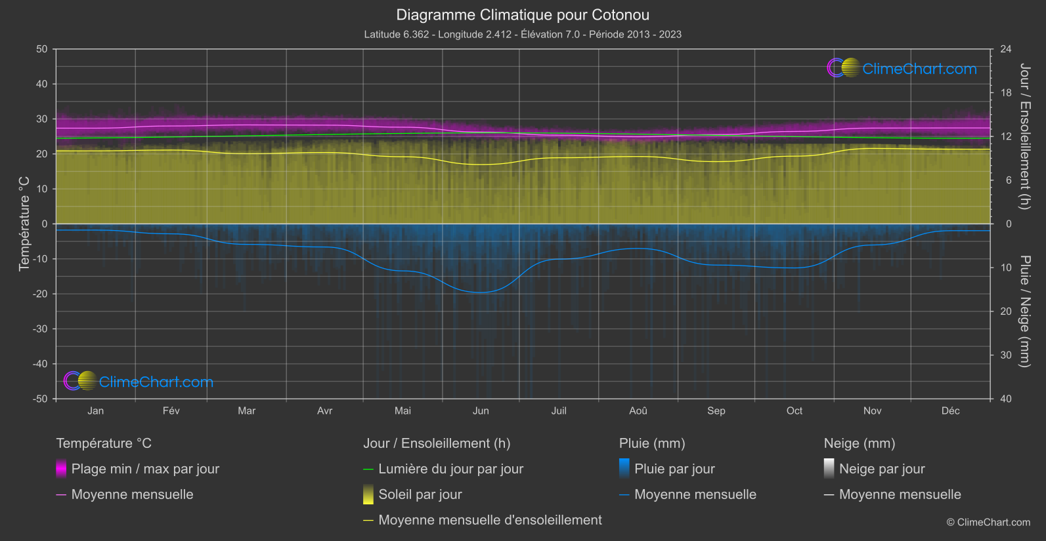
Figure No. 2: Modeling of a typical EAS system
It is clear from this figure that for a 30 m long exchanger, buried at 1.8 m, an average drop of 6 °C in the temperature of the blown air is observed. This drop is sufficient to considerably improve thermal comfort, particularly in well-ventilated and insulated homes. To verify this gain in energy efficiency, probes and sensors will be installed upstream and downstream. This equipment will also be used to detect the humidity level in the pipes.
The figure below illustrates the constructive arrangements for this solution.

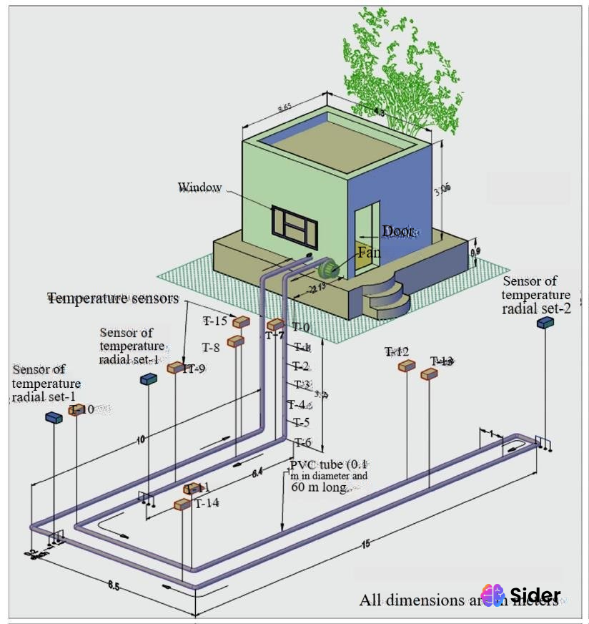
Figure No. 3: Installation of an air-ground exchange device

Despite the equipment, the cooling optimization relies on constructive provisions and changes in behavior in response to the diagnosis established in this study. This involves:
- Reinforce the roof insulation to limit heat loss
- adopt light colors for building facades and roofs
- Build courtyard gardens or plant screens on the East/West facade
- Maintain a minimum flow slope for pipes to avoid the accumulation of water droplets
- Install a filter at the system inlet and provide a maintenance hatch
- Develop technical skills in training centers to democratize the installation, maintenance, and upkeep of EAS
Furthermore, the installation of the underground network requires available land, which is a constraint for houses in co-ownership or where the basement cannot be accessed. Therefore, the technology's development will rely on an information campaign and pilot projects in social housing or public establishments (nurseries, schools). Integration into bioclimatic construction standards could also constitute an accelerator for the diffusion of this innovation.

Conclusion
Surface geothermal energy, via air-to-ground heat exchangers, is a promising option for passive cooling of buildings in Benin, particularly in areas with high temperatures and humidity. Accessible, environmentally friendly, and economical, it deserves to be promoted as part of a strategy to reduce energy consumption and adapt to climate change.

Local pilot studies would be necessary to adapt the systems to Benin's specific climate and geology and to raise public awareness of this sustainable technology. Its implementation can also be integrated into sustainable housing policies, particularly in social housing projects, public or private housing developments, and climate resilience programs.

References
AM Online Projects - Alexander Merkel. (2025). Climate-Data. Accessed May 18, 2025, at Climate-Data: https://fr.climate-data.org/afrique/benin-42/
Batier, C. (2016). Thermal comfort and energy in social housing in a Mediterranean environment: from an occupant behavioral model to architectural strategies. University of Montpellier.
Belloufi Y, Y., Brima, A., Atmani, R., Moummi, N., & AISSAOUI, F. (2016). Theoretical and experimental study of air cooling by an air/ground geothermal exchanger. Larhyss Journal, 121-137.
Chtioui, F. (2023). Study of passive building cooling by integrating a water retention system. University of La Rochelle. La Rochelle: University of La Rochelle.
El-Maktoume, D. (2023). Modeling of a habitat equipped with an adsorption air conditioning unit powered by a geothermal heat pump. University of Perpignan; University of Antananarivo. University of Perpignan; University of Antananarivo.
Kaboré, B., Ouedraogo, WP, Kam, S., Ousmane, M., & Bathiébo, DJ (2017). Air-ground heat exchanger in Ouagadougou: Literature review, analytical study and experimentation. Renewable Energy Review, 20(3), 363-375.
Youssouf, I., & Lawani, M. (2002). Beninese soils: classification in the world reference database. FAO.

